Universitatea Tehnica din Cluj-Napoca
Computer Aided Graphics – Project
4 parts

Technical University of Cluj-Napoca
Faculty of Automation and Computer Science
Department of Automation
Discipline: Computer Aided Graphics

CAG Project
4 parts - deadlines

May 25
OpenGL

May 2
Lisp
April 19
Drafting 2
April 9
Drafting 1
CAG
Project

CAG
Project

Student : Mastan Andrei-Mircea | Coordinator:
Group: 30311 | Lecturer Eng. Iulia STEFAN, PhD

Summary
2023-2024
Universitatea Tehnica din Cluj-Napoca 0
Explanatory Note 2
1. Drafting 1 3
1.1 Bibliography Drafting 1 7
2 Drafting 2 8
2.1 Bibliography Drafting 2 8
3 LISP 8
3.1 Bibliography LISP 8
4 OpenGL 9
4.1 Bibliography OpenGL 9

Explanatory Note

- Use the current template to finalize the documentation.
- For each deadline, read the specific details for the corresponding chapter.
- At the lab exam, bring the zip file with all the resources (you already uploaded the files during the semester for each assignment defined by the teacher)!

- Drafting 1
Object used: Angle Bracket

Angle brackets are used to fasten certain pieces of furniture to a wall or another
object. It is a simple L shaped metal piece with holes for screws on each side. In our case it has one large hole for the side that is meant to be placed against the wall, and three holes on the other side.

Commands used:
UNITS was necessary to set the measurement unit to milimeters.
LINETYPE was used to dedfine the dotted line type used for covert edges and other imaginary lines.
LINE, PLINE and PEDIT commands were used for most of the drawing, creating and editing objects such as borders, alignment elements, the indicator, base outlines and sides of the piece.
DONUT was used for the creation of the 4 holes that exist in the piece.
GRID AND SNAP settings to set the grid and snap in the most suitable manner.
FILLET to smooth out the edge of the part .
CHAMFER was used to adjust the corners so that they match the real ones of the part.
TEXT command was used to annotate inside the indicator spaces.
DIMLIN and DIMANG commands were used for placing the essential measurements and dimensions of different lines and angles of the object.
GROUP for grouping together object so they would be easier to move or copy
COPY to copy certain elements so I would not have to design them again.

Pictures:
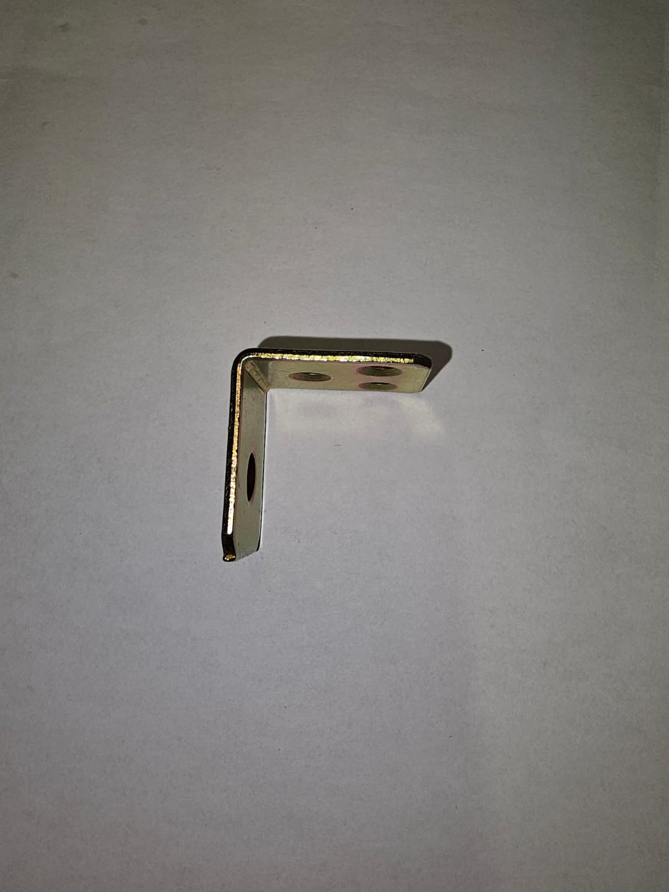
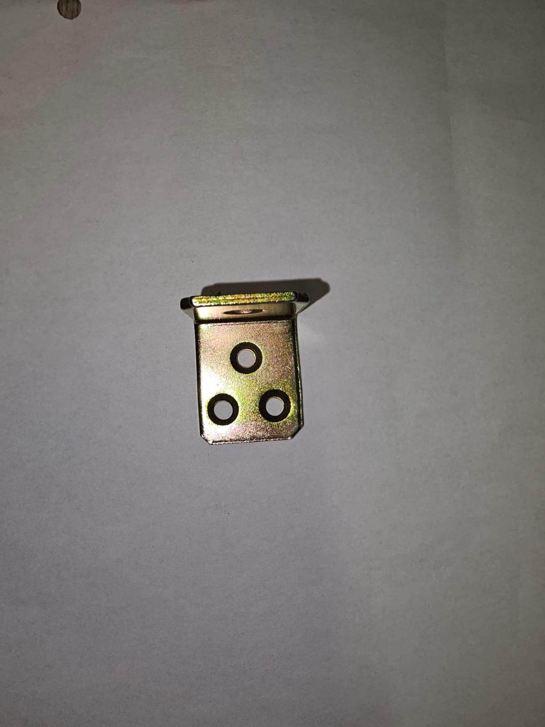
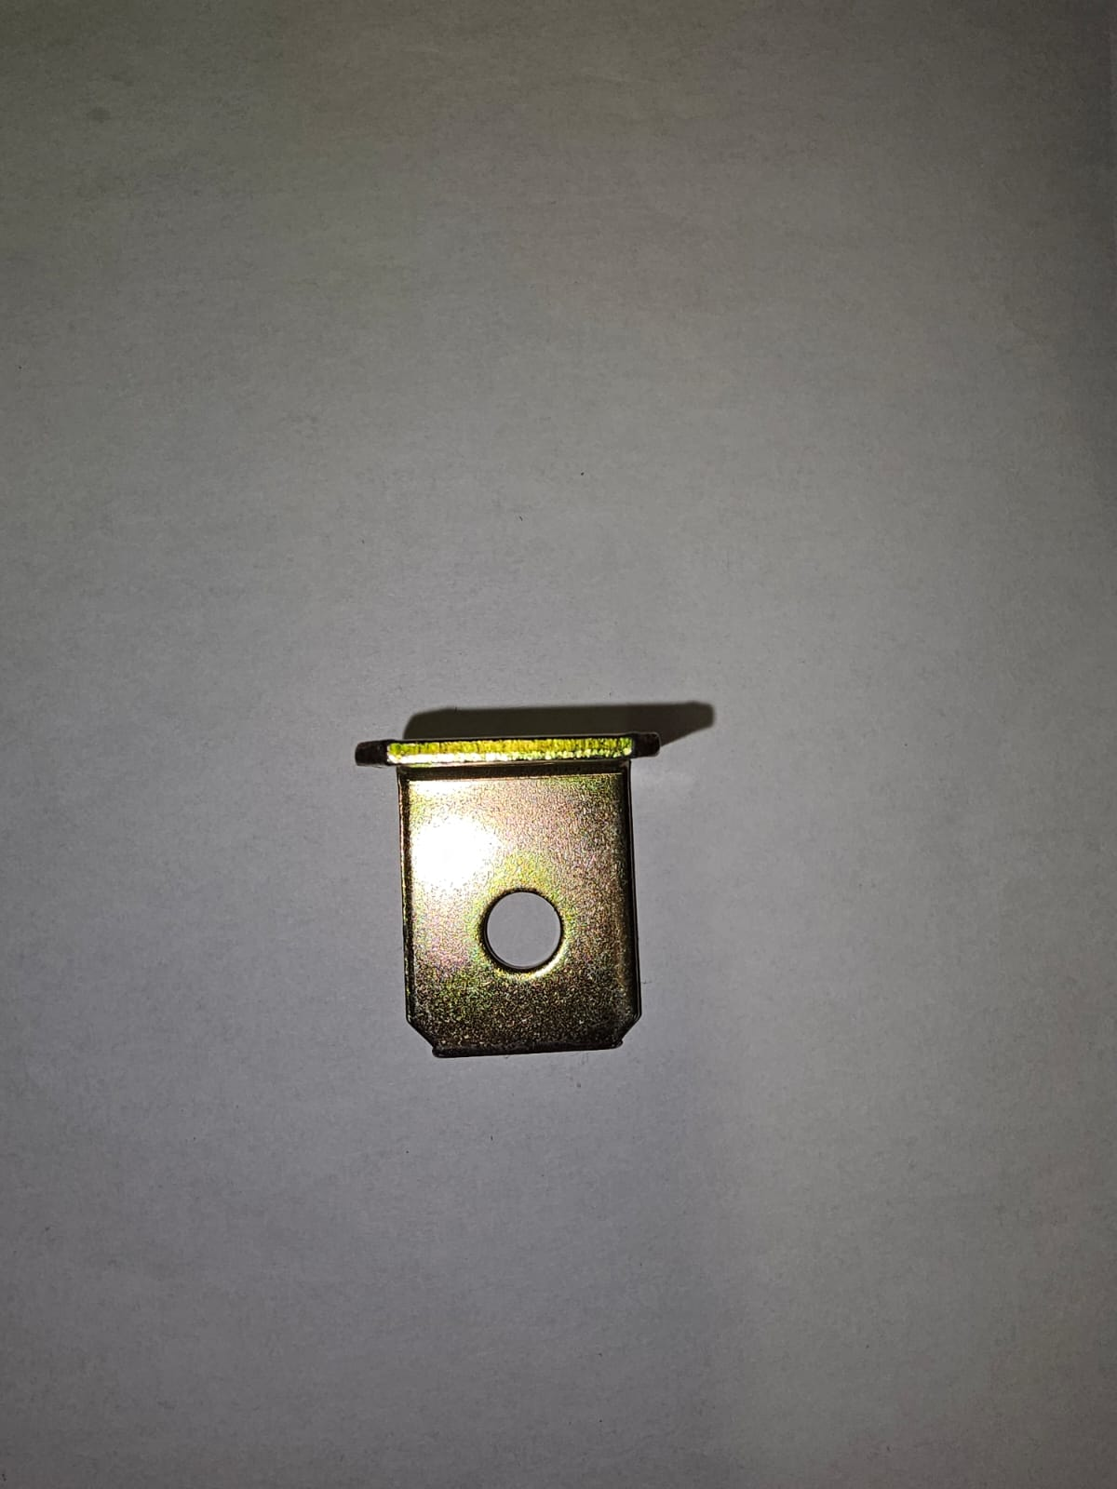

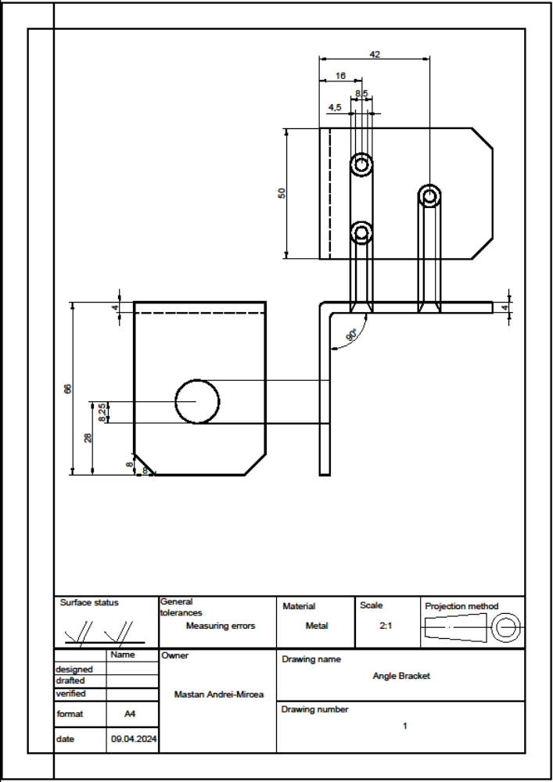

Bibliography Drafting 1
- AUTOCAD 3D EN
- ANSI ISA 5.1 1984 (R1992) Instrumentation Symbols and Identification
- Hasurarea in desenul industrial
- Norme generale pentru reprezentarile grafice industriale en
- Reguli de reprezentare a desenului de ansamblu
- Arhiva elemente desen tehnic
- Autodesk forums, https://forums.autodesk.com/t5/autocad/ct-p/8 last visited 09.04.2024.

Drafting 2

Introduction
For this part of the project, this time I have chosen as reference material a “Piping and Instrumentation Diagram”, for short P&ID, that depicts a steam heat exchanger. A heat exchanger is a processing unit in which steam is used to heat up a liquid material.
.

Reference material
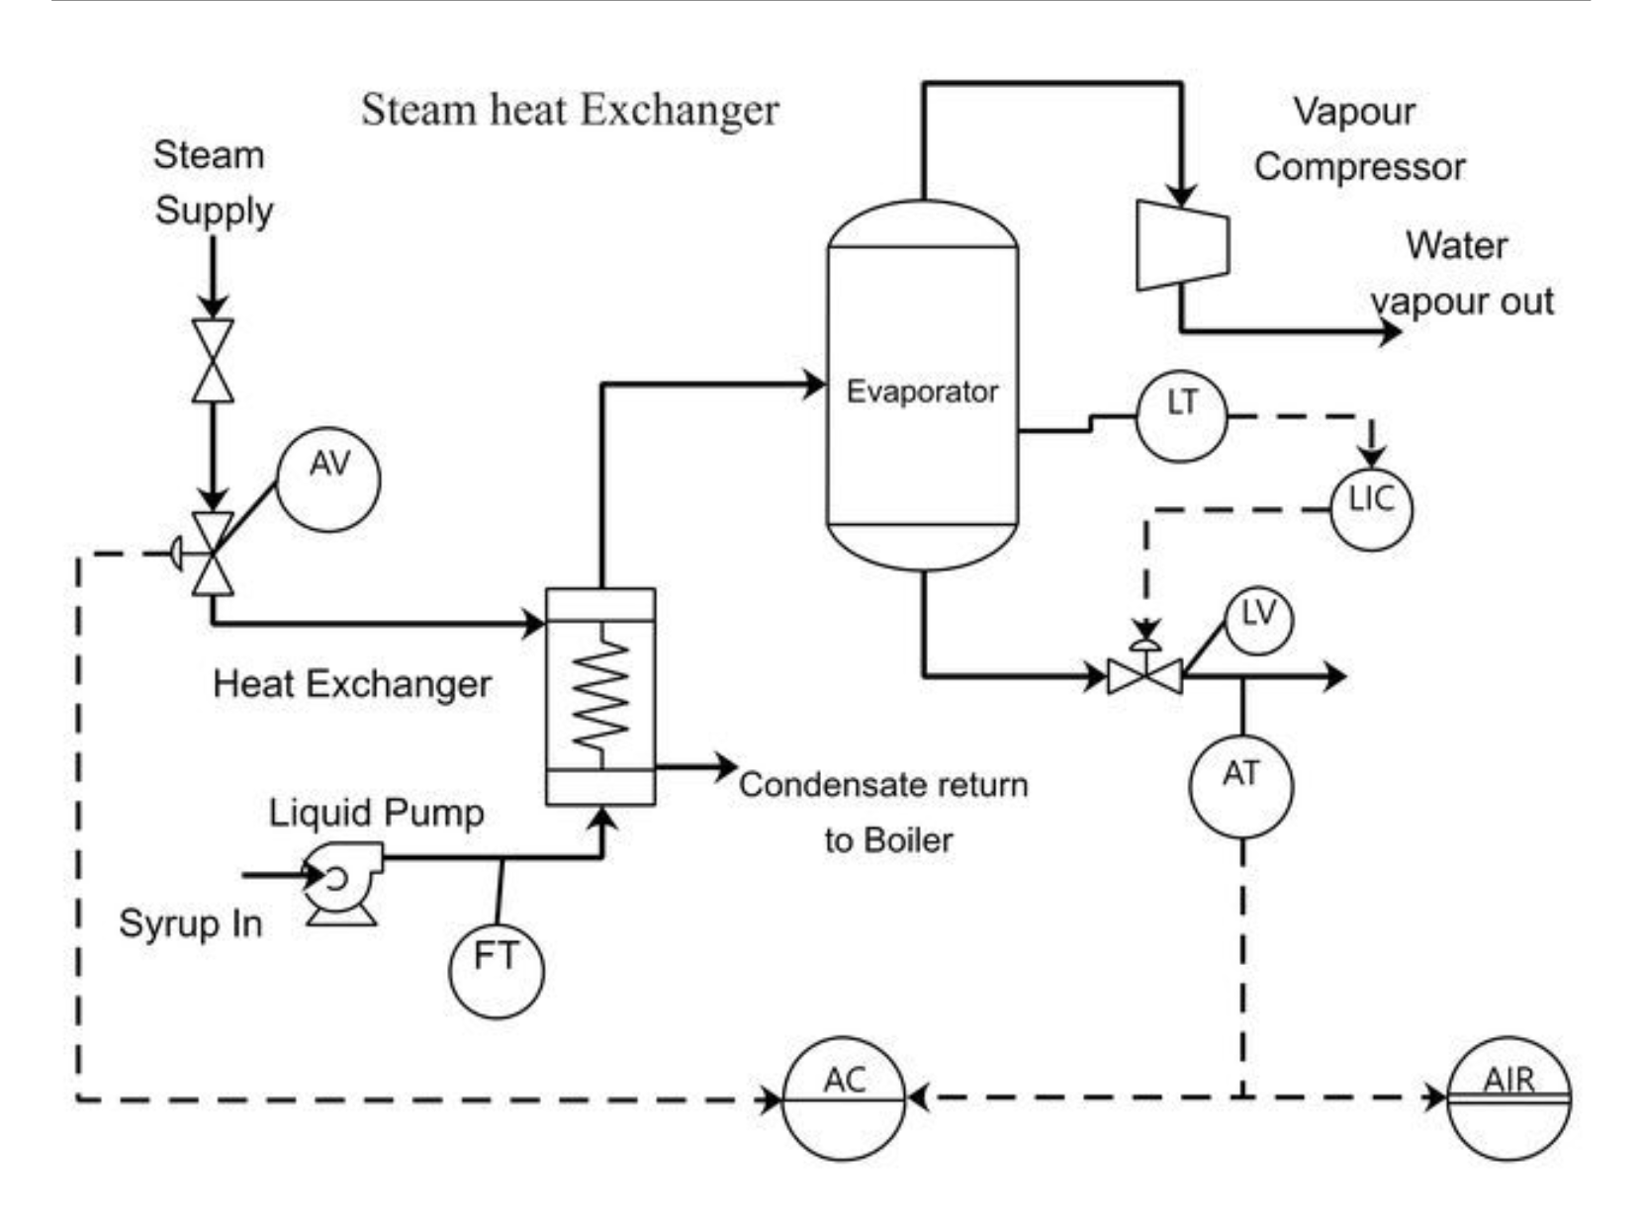

Representation
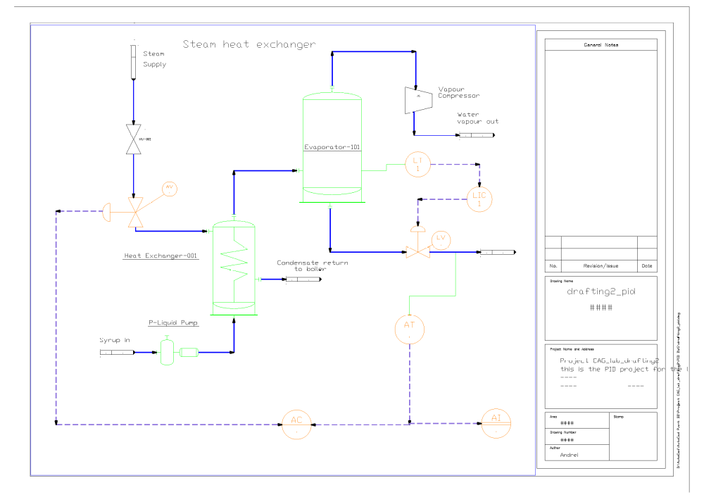

Elements and commands
- Vessel- used as an evaporator for the heated syrup and also used to represent a heat exchanger which heats the syrup using hot water vapour
- Gate valve- to control the steam supply manually
- Control valve- to enable the passing of steam and heated concentrated syrup in a controlled manner
- Concentric reducer- used to symbolize a vapour compressor (reduces the diameter of the pipe)
- Off page connector- used to signal pipes that come in and go outside of our drawing
- Pump- used to pump syrup into our steam heat exchanger
- Level transmitter- attached to the tank to measure the level of the liquid within
- Analyzer transmitter
- Analyzer indicator

Commands:
- TOOL PALETTES – this is where all the elements were added from
- ASSIGN TAG – to assign a tag to certain elements
- TEXT – for additional descriptions
- ROTATE – to rotate certain parts so they fit in the drawing accordingly

Bibliography Drafting 2
- AUTOCAD 3D EN
- ANSI ISA 5.1 1984 (R1992) Instrumentation Symbols and Identification
- Hasurarea in desenul industrial
- Norme generale pentru reprezentarile grafice industriale en
- Reguli de reprezentare a desenului de ansamblu
- Arhiva elemente desen tehnic
- Autocad plant 3D forums, https://forums.autodesk.com/t5/autocad-plant-3d-forum/bd-p/371, last visited 16.04.2024
- Pinterest, last visited 16.04.2024

LISP
- This LISP function recognizes all the circles and lines in a drawing and moves them to a point given by the user such that the circle’s centers and the midpoints of the lines are situated on that point
- This is the source code:
(defun c:concentric ( / ss1 i userInput entname ent entStartPoint entEndPoint entMidPoint dx dy newStartPoint newEndPoint entCenter newCenter)
;; Select all line and circle entities in the drawing
(setq ss1 (ssget "x" '((0 . "LINE,CIRCLE"))))
(setq i 0)
;; Get the new point from the user
(setq userInput (getpoint "\nPlease give me a new point for all midpoints and centers: "))

;; Iterate over each selected entity
(repeat (sslength ss1)
(setq entname (ssname ss1 i)) ; Get the entity name
(setq ent (entget entname)) ; Get the entity data list

(cond
;; If the entity is a line
((eq (cdr (assoc 0 ent)) "LINE")
;; Get the start and end points of the line
(setq entStartPoint (cdr (assoc 10 ent)))
(setq entEndPoint (cdr (assoc 11 ent)))
;; Calculate the current midpoint of the line
(setq entMidPoint (list (/ (+ (car entStartPoint) (car entEndPoint)) 2)
(/ (+ (cadr entStartPoint) (cadr entEndPoint)) 2)))
;; Calculate the displacement needed to move the midpoint to the user-specified point
(setq dx (- (car userInput) (car entMidPoint)))
(setq dy (- (cadr userInput) (cadr entMidPoint)))
;; Calculate the new start and end points
(setq newStartPoint (list (+ (car entStartPoint) dx)
(+ (cadr entStartPoint) dy)))
(setq newEndPoint (list (+ (car entEndPoint) dx)
(+ (cadr entEndPoint) dy)))
;; Update the start and end points in the entity data list
(setq ent (subst (cons 10 newStartPoint) (assoc 10 ent) ent))
(setq ent (subst (cons 11 newEndPoint) (assoc 11 ent) ent))
)

;; If the entity is a circle
((eq (cdr (assoc 0 ent)) "CIRCLE")
;; Get the center point of the circle
(setq entCenter (cdr (assoc 10 ent)))
;; Calculate the displacement needed to move the center to the user-specified point
(setq dx (- (car userInput) (car entCenter)))
(setq dy (- (cadr userInput) (cadr entCenter)))
;; Calculate the new center point
(setq newCenter (list (+ (car entCenter) dx)
(+ (cadr entCenter) dy)))
;; Update the center point in the entity data list
(setq ent (subst (cons 10 newCenter) (assoc 10 ent) ent))
)
)

;; Modify the entity with the updated data list
(entmod ent)
(entupd entname) ; Ensure the change is applied

;; Increment the loop counter
(setq i (+ i 1))
)
(princ)
)
- Before:

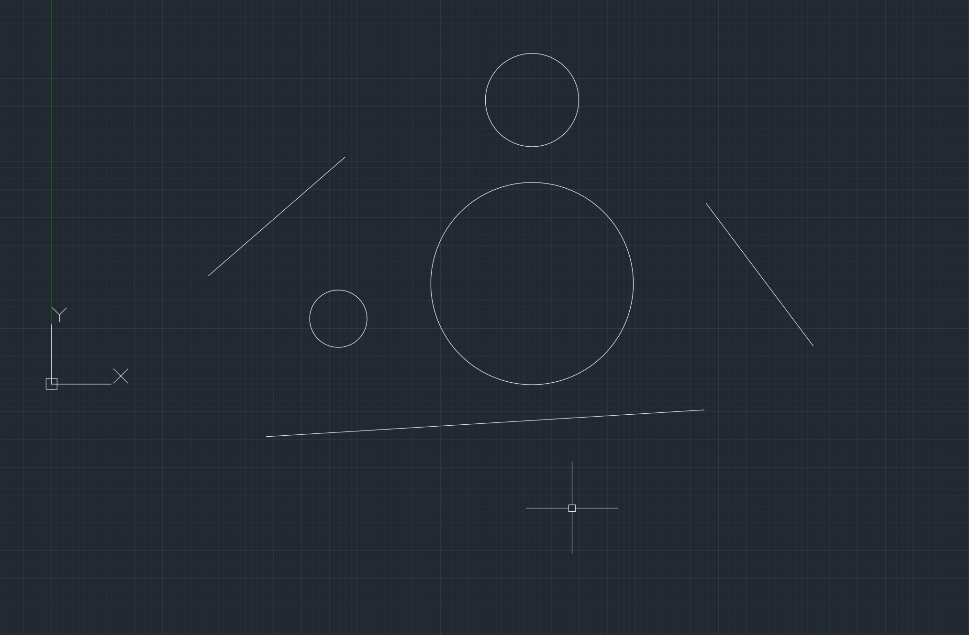

- After:

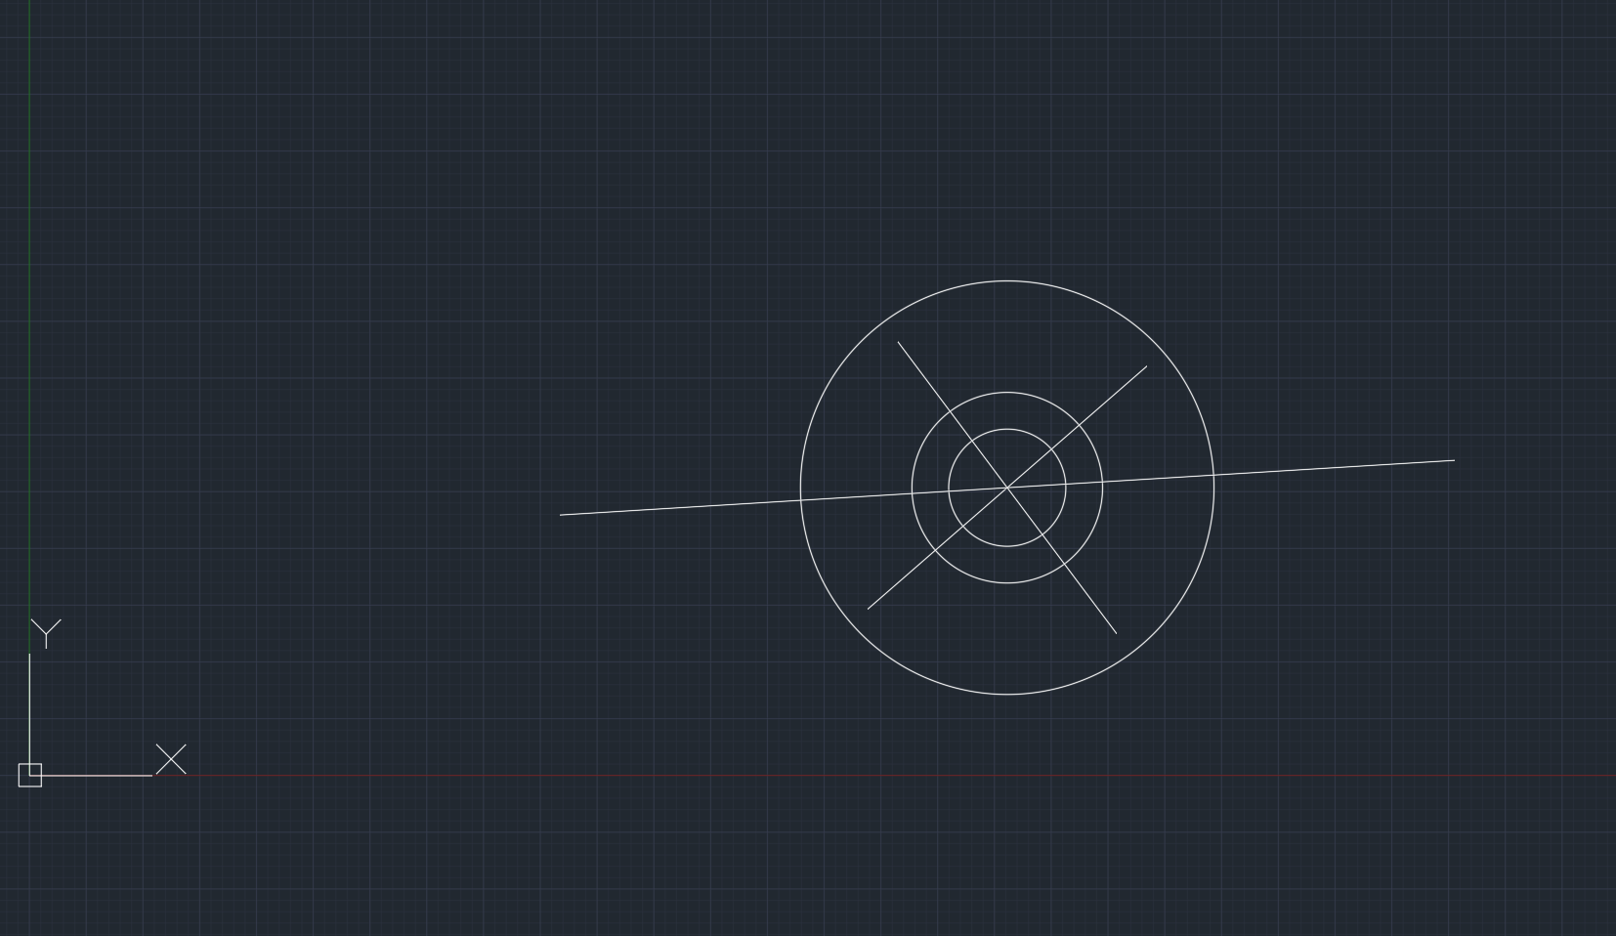

Bibliography LISP
- https://forums.autodesk.com/t5/visual-lisp-autolisp-and-general/bd-p/130, last visited on 27.05.2024
- https://www.tutorialspoint.com/lisp/index.htm, last visited on 27.05.2024
- CAG5_6_LISP_1.url, last visited on 27.05.2024
- CAG7_8_LISP_2.url, last visited on 27.05.2024

OpenGL
- 
- 

#include <windows.h>
#include <GL/gl.h>
#include <GL/glu.h>
#include <GL/glut.h>
#include <iostream>

float tank1Level = 0.5f;
float tank2Level = 0.1f;

// Function to draw a rectangle
void drawRectangle(float x, float y, float width, float height, float r, float g, float b) {
glColor3f(r, g, b);
glBegin(GL_QUADS);
glVertex2f(x, y);
glVertex2f(x + width, y);
glVertex2f(x + width, y + height);
glVertex2f(x, y + height);
glEnd();
}

// Function to draw the scene
void drawScene() {
glClear(GL_COLOR_BUFFER_BIT);

// Tank dimensions
float tankWidth = 0.4f;
float tankHeight = 0.6f;
float pipeWidth = 0.8f;
float pipeHeight = 0.1f;

// Draw tanks
drawRectangle(-0.8f, -0.5f, tankWidth, tankHeight, 1.0f, 0.9f, 0.0f); // Tank 1 (outline)
drawRectangle(0.4f, -0.5f, tankWidth, tankHeight, 1.0f, 0.9f, 0.0f); // Tank 2 (outline)

// Draw tank levels
drawRectangle(-0.8f, -0.5f, tankWidth, tank1Level, 0.0f, 0.9f, 1.0f); // Tank 1 level
drawRectangle(0.4f, -0.5f, tankWidth, tank2Level, 0.0f, 0.9f, 1.0f); // Tank 2 level

// Draw pipe
drawRectangle(-0.4f, -0.5f, pipeWidth, pipeHeight, 0.0f, 0.9f, 1.0f); // Pipe at the bottom of the tanks

glFlush();
}

// Function to update the scene
void updateScene(int value) {
// Tank height and transfer rate
float tankHeight = 0.6f;
float transferRate = 0.001f;

// Calculate the middle of the tanks
const float MIDDLE_LEVEL = tankHeight / 2.0f;

// Transfer liquid until both levels reach the middle
if (tank1Level > MIDDLE_LEVEL && tank2Level < MIDDLE_LEVEL) {
tank1Level -= transferRate;
tank2Level += transferRate;
glutPostRedisplay(); // Trigger a redraw
glutTimerFunc(10, updateScene, 0); // Schedule the next update
}
}

// Function to handle window resizing
void reshape(int width, int height) {
glViewport(0, 0, width, height);
glMatrixMode(GL_PROJECTION);
glLoadIdentity();
gluOrtho2D(-1.0, 1.0, -1.0, 1.0);
glMatrixMode(GL_MODELVIEW);
}

int main(int argc, char** argv) {
glutInit(&argc, argv);
glutInitDisplayMode(GLUT_SINGLE | GLUT_RGB);
glutInitWindowSize(800, 600);
glutCreateWindow("OpenGL Example");

// Register callback functions
glutDisplayFunc(drawScene);
glutReshapeFunc(reshape);

// Initialize OpenGL
glClearColor(1.0f, 0.5f, 1.0f, 1.0f);

// Start the animation loop
glutTimerFunc(25, updateScene, 0); // Start the update process

glutMainLoop(); // Start the main event loop

return 0;
}

- Bibliography
- https://www.opengl.org/news/comments/opengl-community-forums last visited: 04.06.2024.
- OpenGLSummary

